- IN SOME PLACES IF THERE IS NEGATIVE NUMBER IN ARRAY , SLIDING WINDOW IS NOT POSSIBLE
- 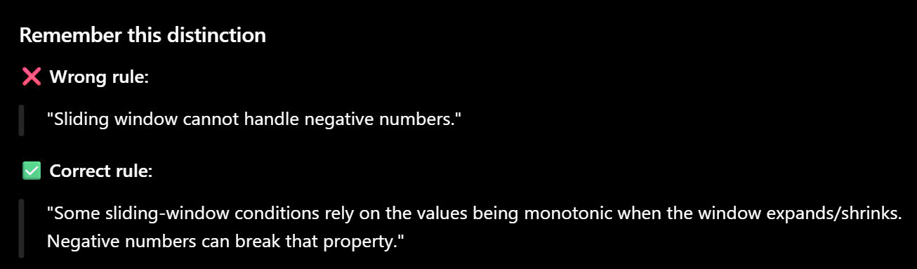
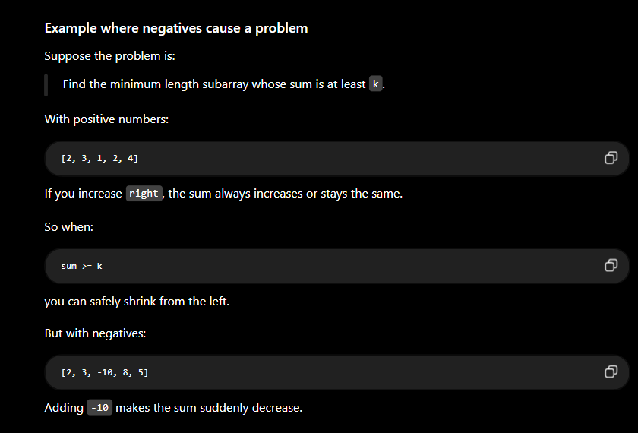

- Don’t do map.remove blindly ..it remove the entire key not one frequency

